Written Summary

Auctions with Anticipated Regret: Theory and Experiment
This paper by Emel Filiz-Ozbay and Erkut Y. Ozbay discusses the question Why do we observe overbidding in first price private value auctions and attempts to explain anticipated regret in auctions. It is important to note that, rather than studying the ante-post reaction of participants, the authors concentrates on how ex-ante anticipation affects the participants’ decisions.
In 1961, William Vickrey derived risk neutral Nash Equilibrium (RNNE) bidding behavior in private value first price sealed bid auction. However, the bidding higher than the RNNE (over-bidding) is the consistent findings of the experimental literature.
In an auction game where there is incomplete information, the best action ex ante may not necessarily be the best action ex post when the information is revealed. This discrepancy between the two often cause regret and the author argues that decision maker reflects this regret in her decision if she can anticipate regret. The two prominent regret that is central to this experimental paper is loser regret and winner regret. Loser regret is felt only by the losing bidders when the winning bid they lost to is within their valuations while winner regret is felt only by winning bidders who realized that they could win with a bid much less than the one they made.
In the paper, the author argue that participants may anticipate regret if they know they are going to receive some feedback. Therefore, bidders who anticipate winning regret may shade their bids and bidders overbid when they anticipate loser regret. There are two objectives that the paper achieved:
- Theoretically show that these regret behaviors are observed in the equilibrium for risk neutral bidders with regret concerns
- Experimentally address the assumption that bidders to anticipate regret and that this anticipated regret is reflect in their bids
The paper is written such that the authors characterize the symmetric equilibrium bidding strategy under loser and winner regret in first price sealed bid auctions in Section I. In Section II, they conducted an experiment with various treatments to check if bidders change their strategies depending on the information that can potentially make them anticipate regret. To avoid any learning regret explanations, the experiment is designed as a one-shot game. In the subsequent sections, the author explain how their theoretical model is capable of explaining the findings of their experimental results and consider the model under three other well-known auctions, second price, English and Dutch auctions.

I. Model
In the auction, only one single object is for sale and there are $N$ potential bidders indexed by $i$. Bidder $i$ assigns a private value $v_{i}$ to the object. Each $v_{i}$ is independently and identically drawn from $\left[v, \overline{v}\right].$ The reservation price of the seller is assumed to be zero.
As in a normal first price sealed bid auction (FP), participants submit their bids in sealed envelopes and the highest bidder gets the object at the price he offered by her bid. It is important to note that, if there is a tie, the tie is broken by assigning the object randomly to the one of the highest bidders.

A. Loser Regret in a First Price Sealed Bid Auction
In the loser regret treatment model, the bidders not only learn about their winning/losing position, but also the winning bid if they lose. The utility of a losing bidder depends on the regret she feels. The loser regret is defined as the function of the difference between her valuation and the winning bid if the winning bid is affordable.
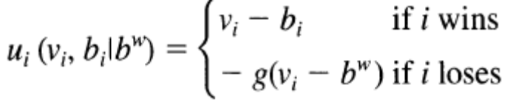
The symmetric equilibrium bidding strategy will satisfy the following condition:
$$E_{X}\left[X \right| X<v]=b^{FP_{lr}}\left(v\right)-E_{X}[ g\left(X-b^{FP_{lr}}\left(X\right) \right| X<v]$$where X is the highest of $N-1 values$.
As we can observe the symmetric bidding strategy is higher than the standard theory and therefore seller’s expected revenue will increase due to the overbidding.

B. Winner Regret in a First Price Sealed Bid Auction
In the winning regret treatment model, bidders know not only their winning / losing position but also the submitted second highest bid if they win. Therefore the winner regret is a function of the difference between actual payment and the second highest bid which is the minimum amount that would preserve her winning position.
$$u_{i}\left(v_{i}, b_{i} \right|{ b}^{2})=\left\{\begin{aligned}v_{i}-b_{i}-h\left(b_{i}-b^{2}\right)if i wins \\ 0 if i loses\end{aligned}\right.$$Knowing that some winner regret may be experienced, bidders may bid less aggressively. The symmetric equilibrium bidding strategy will then satisfy the following condition:
$$E_{X}\left[ X \right| X<v]=b^{FP_{wr}}\left(v\right)+E_{X}[ h\left(b^{FP_{wr}}\left(v\right)-b^{FP_{wr}}\left(X\right) \right| X<v]$$
As we can observe the symmetric bidding strategy is lower than the standard theory and therefore seller’s expected revenue will decrease due to the underbidding.

II First Price Auction Experiment
The important question of this experiment is whether the bidders anticipate any form of regret and if this regret is reflected in their bids. To conduct the FP experiment, various information structures are used so either form of regret might be anticipated.
To have more than one data point from each subject in a one-shot auction experiment, a “bid on list method” is used where subjects reports bids for several different valuations. No subjects participated in more than one session and the number of participants in condition 1,2,3 were 28, 32, and 36. Groups of four bidders were created and each of the bidders is given a list of ten possible valuations. The list is different for each bidder but same lists will be used for each group. The bidders are informed that only one of those ten numbers in their lists was their correct value but they did not know which one. The experimental dollars paid is the difference between her valuation and her bid. At the end of the experiment, a survey adopted from Zeelenberg and Rik Pieters was administered for subjects to rate the intensity of their emotions.
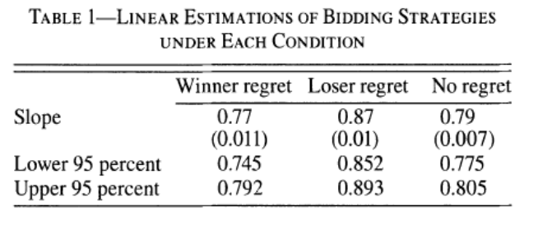
In order to tell more about individual bidding behavior, the author created a bid/value ratio, called the individual bid/value coefficient to measure how bidders share their values. Loser regret condition made most of the subjects bid aggressively but the winner regret condition did not affect the bids of the subjects significantly.
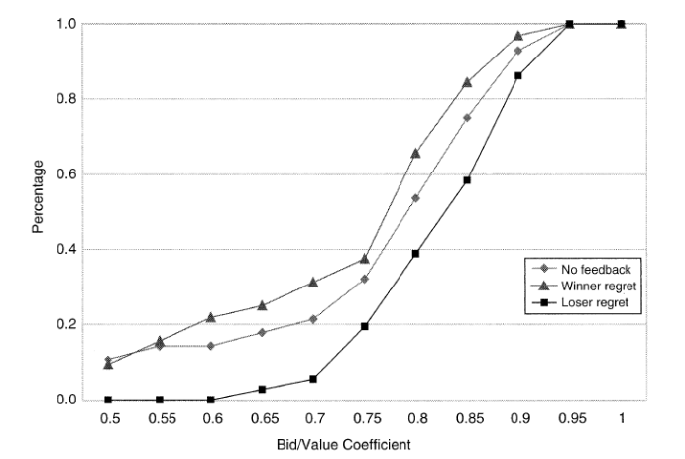

III. Combining Experimental Results with Theory
The RNNE of a bidder with valuation $v$ is the expected second highest valuation given that $v$ is the highest. Bidders anticipated winner regret significantly less than loser regret. Since we found that subjects are capable of anticipating loser regret, they may also be capable of anticipating loser regret in expectation, and therefore still bid higher under the no feedback condition.
In a theory that puts greater weight on an emotion than on monetary payoff in the utility, a money pumping argument can be developed in order to avoid the negative effect of that emotion.

Conclusion
The experiment results support the authors’ hypothesis that the overbidding in first price auctions is derived from the anticipated of loser regret. However, in the experiment the bidders did not anticipate winner regret and hence did not reflect these feelings in their bids.
Due to the one-shot nature of the experiment, the authors only attempt to explain the first-period data of Ockenfels and Selten. Their results, however, suggest that perhaps in repeated setups, the bidders may learn winner regret, although they cannot anticipate it before experiencing it.

Momentum and overreaction in experimental asset markets
Price volatility and investor overreactions are commonplace in experimental asset markets. Understanding the price dynamics in these markets is crucial for designing successful new trading institutions. In this paper, the two most important phenomena that is examined is the boom-bust cycle that first takes prices above the rational value into a ‘bubble’, only to be followed by a rapid decline in prices and a prolonged undervaluation of securities. According to the experimental results, the best predictive methods are the momentum model and the expert human forecasters.
In the asset markets, experimental economics has shown that participants have a tendency to not only examine the fundamental value of the asset but also the reactions and motivations of other traders.
The bubble experiment performed in the paper utilized the same experimental protocol of Smith et al in 1988. Participants were given a distribution of cash and shares which will pay a dividend, with expected dividend of 24 cents, at the end of each of 15 periods. Therefore, the fundamental value of the asset is $3.60 at the beginning of the experiment and decreases by $0.24 each period until it becomes worthless after the 15th period.
Rational expectations would predict the trading price to be similar to the fundamental value with some fluctuations due to randomness of trading. However, based on past experiments, one usually observes an initial trading price that is well below the realistic value and the overshoots the fundamental value in the intermediate periods, creating a ‘bubble’, before crashing near the end of the experiment. This shows that actions and strategies of other traders provide the only element of uncertainty of participants.
The four basic objectives of this paper is to:
- Understand the reasons for the formation of a bubble and its magnitude
- Test mathematical ideas that can be used to predict the entire time evolution of an experiment before it starts
- Modify the differential equations so that an updated prediction can be made after each period
- Compare the models to several standard prediction models (e.g. excess bids, time series forecasting, random walk, and ‘expert’ human forecasters)
The author also hypothesized that the size of the bubble in an experiment should be an increasing function of the extent of undervaluation at the outset. So a lower price restriction in the first period will cause a larger bubble while a price restriction closer to the initial fundamental value will reduce the size of the bubble. The intuition is that a larger initial undervaluation motivates traders to buy but the trend becomes robust overtime causing the asset to become overvalue. This causes some selling by traders with positive differences and causes a break in the system near the end of experiment.

The Momentum Model
The main feature of the momentum model focuses on the flow of finite supply of assets in the form of cash or financial instrument to derive a system of differential equations in which supply and demand exhibit dependence on price trend as well as price itself.

The Experimental Design
Subjects in the experiment were allowed to trade the asset each period prior to knowing that period’s dividend draw using the double auction trading mechanism. Each trader has an expected value of $20.25 if they did not trade in the experiment and just held onto their initial endowment.
Two initial baseline experiment were used to determine the dynamic price path for the momentum model. The parameters were then used to determine the price predictions when the opening price is restricted to trade in a specified range. The first set of experiment used the standard $0.24 dividend while the second set double the dividend distribution (0.48 in experiment money) but there would be no difference in real money space.

Results
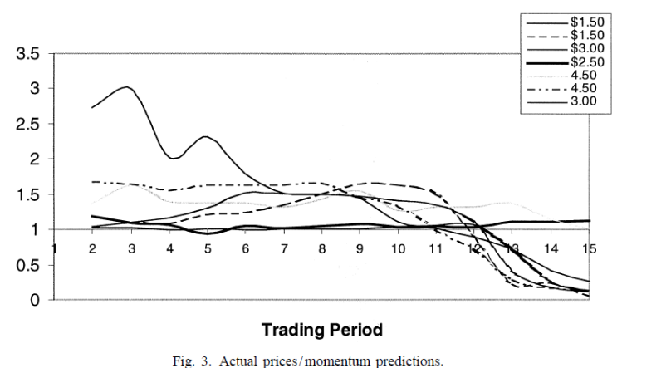
The momentum model under-estimates the mean contract price in the early trading periods and overestimates the price in the later trading periods. The sum of square errors show that the momentum model out-performs the rational expectations model.
Using the regression model $Sum_{i}=α+β\left(P_{a}^{i}\left(0\right)-P^{i}\left(1\right)\right)+ϵ$, it shows that a larger initial undervaluation produces a larger positive price movement. However, the momentum model did not consistently predict the price path within 5% and it misses the turning points and under-shoots prices in the later periods of the experiments. An updated momentum model is then constructed where the model can only predict two periods in advance and update from the price information.
To compare the performance of the updated model with other predictive models, a new experiment is conduct where no price controls were used. Sealed Offer-Bid (SOB) auction is used instead of the continuous double auction because then only one price is used for each trading period and thus eliminates the need to rely on average price predictions and avoid outliers.
In the expert trader model, highest earners from previous experiments were used to be price forecasters in the experiments. The ARIMA (0,1,0) is the random walk model where the next trading period price has expected value that equals that of the current period. The second model is the ARIMA (1,1,1) where the $α$ in the model explains the changes between differences in the current trading periods and the differences in the previous trading periods. Lastly, the excess bid model, a one-period ahead price forecast, estimates price change from excess bids using a Walrasian type adjustment process.

Results
The author examine the performance on the different models based on the relative Absolute Forecast Errors.
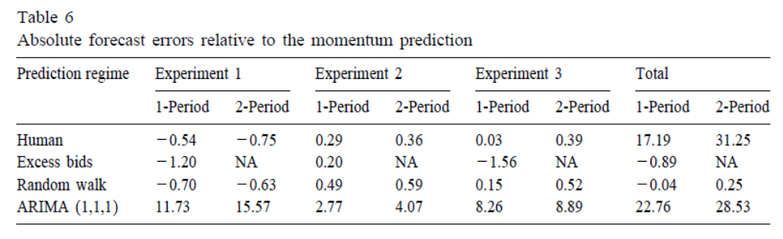
The results can be summarized as follow. The Momentum Model and Human forecasters’ price predictions have similar forecasting efficiencies. The Excess Bids model outperforms the Momentum Model and has an overall absolute forecast error that is almost half that of the momentum model. The random walk and Momentum Model have similar predictive efficiencies in the one-period ahead forecasts, but the Momentum Model is superior for the 2-period ahead forecasting. Lastly, the ARIMA (1,1,1) is slightly more efficient in the one-period ahead forecasts while the Momentum Model is more efficient for the 2-period ahead forecasting.
The result of the paper shows that the updated momentum model can be used to make predictions of the entire experiment before the experiment begins and during the experiments itself. Finally, the momentum model appears to be the only one that indicates a downturn in prices in advance.

The Curse of Knowledge in Economic Settings: An Experimental Analysis
The curse of knowledge is a phenomenon where better-informed agents are unable to ignore private information even when it will result in suboptimal outcomes. In this paper, the authors – Camerer, Loewenstein, and Weber – examine the assumption that better-informed are capable of reproducing the judgments of less-informed agents in an asymmetric information environment. The authors found that the curse is prevalent is that market forces reduce the curse by approximately 50 percent but do not eliminate it.

Introduction
The conventional assumption is that better-informed agents can accurately anticipate the judgments of less-informed agents in an asymmetric information environment. However, in predicting the judgments of others, agents more often than not are unable to ignore the additional information they possess despite the fact that they may suffer from it.
The important question for economics is whether the curse will harm the allocation of resources in economic settings. The paper aims to address three argument:
- The hypothesis that the curse may result from careless thinking and lack of financial incentive
- Feedback might reduce or eliminate the bias due to learning
- Agents who are less bias might reduce the market-level effects because they know they are less biased and will exert disproportionate influence
The law of iterated expectations states that if $I_{1}$ includes $I_{0}$, then $E\left[E\left(X \right| I_{0}\right)\left| I_{1}\right]=E\left(X \right|I_{0})$. However, when the curse of knowledge occurs, forecaster with better information overestimates the scope of $I_{0}$. So $E\left[E\left(X \right| I_{0}\right)\left| I_{1}\right]=wE\left(X\right|I_{1})+\left(1-w\right)E\left(X \right|I_{0})$ where w measures the degree of curse of knowledge.

Experimental Design
The experiment consists of two stages:
- In the first stage, predictions of eight actual companies’ earnings were collected
- In the second stage, conducted 2 months later, a second group of subjects were informed of the actual earnings and trade the assets. The second group did not know the exact amount of the dividend but knew the first group’s predictions.
For the second stage, the market were split into two periods and there are eight identical markets in total. At the beginning of each period, these “informed subjects” are endowed with two assets and $50 in cash which has to be repaid at the end with a $3.50 tax. At the end of period B, after the dividends were paid, assets held from period A and B expires.
The dividend amount was equal to the mean earnings prediction of subjects in the first stage of the experiment. The additional information that the informed subjects get is the actual earnings of 1980.
If these subjects suffer from the curse of knowledge and market forces do not erase it, market prices will be biased away from $E\left(1980 earnings \right|I_{0})$ in the direction of $E\left(1980 earnings \right|I_{1})$

Experimental Results
There will not be any predictions that is favored since risk aversion will sometimes cause the pure-bias prediction to be below the no-bias prediction. The results show that judgments and prices are close together. Price generally begin between the pure-bias and no-bias predictions and move away from the pure-bias prediction slightly. The equilibrium prices are between the pure-bias and no-bias predictions.
A dummy variable for $B$ periods is included to test whether the degree of bias shrinks between periods A and B. Bias was indeed smaller in period B for 11 out of the 13 comparisons while larger in two of the 13 comparisons.
In 54 percent of the cases, judgments did not change at all. In the remaining cases, 63 percent indicated a reduction in bias thus market experience does reduce bias.
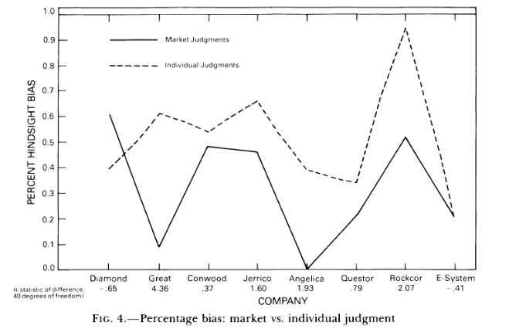
In a subsequent experiment, participants were told the actual estimates by the first group after they make their predictions as the feedback treatment. There is no difference between the biases of subjects in the incentives and feedback conditions; feedback apparently did not reduce bias. By comparing the original experiment (market experience) and the subsequent experiment with feedback and incentive treatment (individual experience), the result shows that individuals in both conditions exhibit some positive degree of bias, but the market reduces bias by about half.
It is argued that the market experience reduces bias because less biased subjects trade earlier and more often, thus signaling their information to more biased subjects. Subjects were asked to predict their ranks relative to other traders to measure self-insights. The substantial correlations between predicted and actual ranks show that traders seem to know who they are and the less biased traders act disproportionately often but the effect is small in magnitude.

Conclusion
As shown, the curse of knowledge does exist but market experience reduces it significantly. A strong explanation is that the error-correcting power is not derived from the feedback they receive but rather from the disproportionate activity of more rational traders.

